Christmas newsletter 2021
I hope that you are all well and recovered from our great concert. How lucky we were to be able to sing and thank you all for your great support
Now we move on to our next concert. A choir is only as good as its next concert, so let’s prove we are the best.
Arrangements for next term
We are still hopeful that term will start on January 4th. I have not heard anything different from the school as yet but clearly this is a difficult time and arrangements may change so please check your emails regularly.
After a very successful autumn term and concert we need to build on that success, so I hope that attendance will continue to be good and that you all take on board the new music which is very different to the music from last term. The music is new to most of us so attendance at rehearsals will be very important as we have only 12 rehearsals before the concert in March. We will be having parts rehearsals and at least one Saturday workshop. It is likely that Thomas Mottershead will be helping this term as we have now offered him an assistant conductor contract. If there are difficulties with face to face rehearsals we may need to have some Zoom rehearsals.
The Spring concert will be on March 19th at the Cathedral. The programme is a celebration of British music with music by Vaughan Williams, Hubert Parry and William Matthias
2022 marks the 150th anniversary of the birth of Vaughan Williams and the Platinum Jubilee of Her Majesty the Queen. Both of these anniversaries are reflected in the choice of music.
This is the draft programme for the concert.
The Old Hundredth – Ralph Vaughan Williams Chorus
Serenade to Music – Ralph Vaughan Williams Chorus and quartet.
Five Mystical Songs – Ralph Vaughan Williams Chorus and baritone
Hear my words, ye people – C H H Parry chorus and semichorus and solos
I was glad – C H H Parry Chorus and semichorus
Some pieces are still to be chosen.
All the music can be downloaded and printed at home. I will be sending put the links separately.
We will be printing off dome copies for those of you who are unable to download or print.

60th anniversary concert.
As explained previously this has had to be moved from the original date in April because of a clash with the BBC performance of St Matthew Passion.
The concert will now take place in November on 19th but the venue is still to be decided.
We will still be performing the St John Passion IN GERMAN. We will be using the New Novello edition so please make sure that you have that copy well before we start the rehearsals after Easter. This is really important as it causes great problems if we are not all singing from the same edition, as we discovered in the Vivaldi.
Summer concert 2022 This will be a charity concert in aid of the National Autistic Society on July 8th or 15th ( To be confirmed) the concert will be held at St Albans Church Cardiff and will feature music from European Sacred Music and other light works
Christmas wishes.
No cards from me this year as I have made a donation to Crisis in lieu of cards. I know that some of you have had to change your plans because of new Covid restrictions so I hope it is a happy Christmas wherever you are.
A very happy Christmas and a peaceful and healthy new year to you all with great music making
From the committee
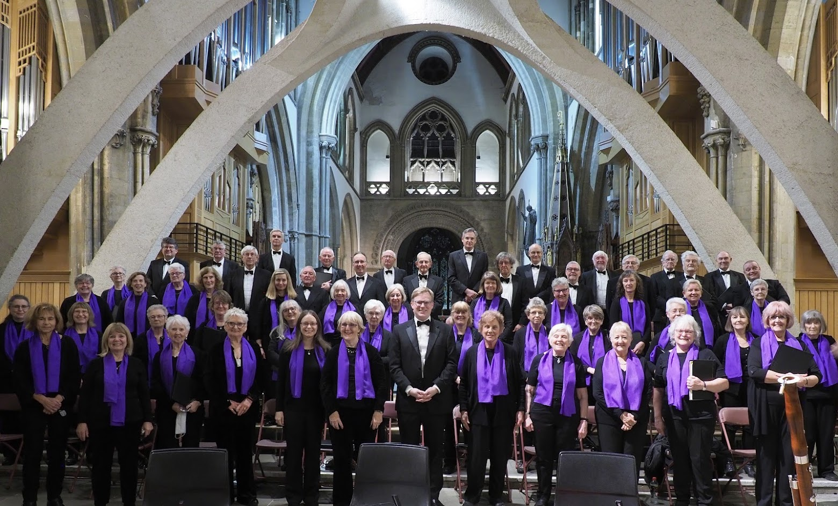
Thanks to John Nudd for this great picture.

