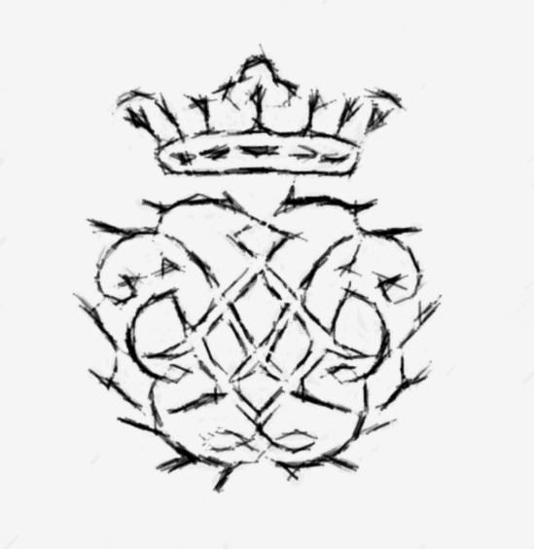
CARDIFF BACH CHOIR
SPRING CONCERT
Llandaff Cathedral
Saturday April 21st 2018 7.30pm

Rossini Petit Messe Solennelle
Vierne Messe Solennelle
Vierne Organ Music
Conductor Luke Spencer
Soprano Claire Watkins Mezzo Soprano Siân Menna
Tenor Gareth Morris
Bass Andri Björn Róbertsson

Organist Philip Aspden
Pianist Sally Tarlton Harmonium Greg Crooks
Tickets £15 : students £10 : under 18 free
From Choir members, Cathedral Shop, Garlands Llandaff
Online at http://www.ticketsource.co.uk/date/464275
www.cardiffbachoir.org.uk

